|  |  |  |
| --- | --- | --- |
|  | | |
| Introduction to AVIX Suite and IBS-Formatted Digital Work Instructions | | |
| **Doc. No.:** | **Rev.: 01** | **Date effective: 07/26/2024** |
| **Approved:** | **Written: M.Glavan** | **Page 1 of 21** |

1. **PURPOSE**

This document provides instructions for gaining access to AVIX Suite as well as an introduction to making Work Instructions in IBS format.

1. **SCOPE**
   1. This document applies to all involved in the creation of Work Instructions through the continuous improvement initiative.
   2. The details of this document will remain limited to AVIX, however, Python apps for work instruction synthesis developed by Mirko Glavan circa June 2024 are completed and available should AVIX Suite be insufficient for the needs of the plant.
2. **RESPONSIBILITY**
   1. It is the responsibility of the user to ensure that the correct preparations have been completed prior to moving forward with AVIX Suite. A file storage architecture and display location are among the items that must be in place.
   2. Note that this document will not detail nor make recommendations as to how AVIX Suite should be managed amongst an industrial workflow. AVIX Suite should be used to enhance production while interrupting it minimally.
   3. Additionally, it is the responsibility of the user to ensure that information, statistics, and the generated product via AVIX is accurate, representative, and accessible.
3. **REFERENCE DOCUMENTS AND DEFINITIONS**
   1. AVIX Suite User Manual [here](https://hydacna-my.sharepoint.com/:b:/g/personal/mirko_glavan_hydacusa_com/EQpckMBfbS9HvmimBQaoD0kBBhnGgLIrNqv0MFXxEE1KRA?e=Di0Mpq)
   2. Python Work Instruction Apps – Documentation by Mirko Glavan [here](https://hydacna-my.sharepoint.com/:w:/g/personal/mirko_glavan_hydacusa_com/EUmnm7uomulBkIHhXHo421cBiUZ-rrK6e6kjoK-HxoCbGw?e=G1ElWr)
   3. Python Work Instruction Apps – Link to Mirko Glavan’s GitHub [here](https://github.com/mglavan07/WorkInstructions)
   4. IBS Work Instructions Format – Example [here](https://hydacna-my.sharepoint.com/:x:/g/personal/mirko_glavan_hydacusa_com/EduhFqunAkNMqAUuErRJIG8BKN003soPVhueSBOE2n-J6A?e=iZ1CGm)
4. **Download AVIX Suite**
   1. AVIX Suite can be downloaded from the Company Portal. This section details the exact method for doing so.
   2. First, navigate to the Company Portal application on the device AVIX is intended to be installed on. The Company Portal should appear as seen below.

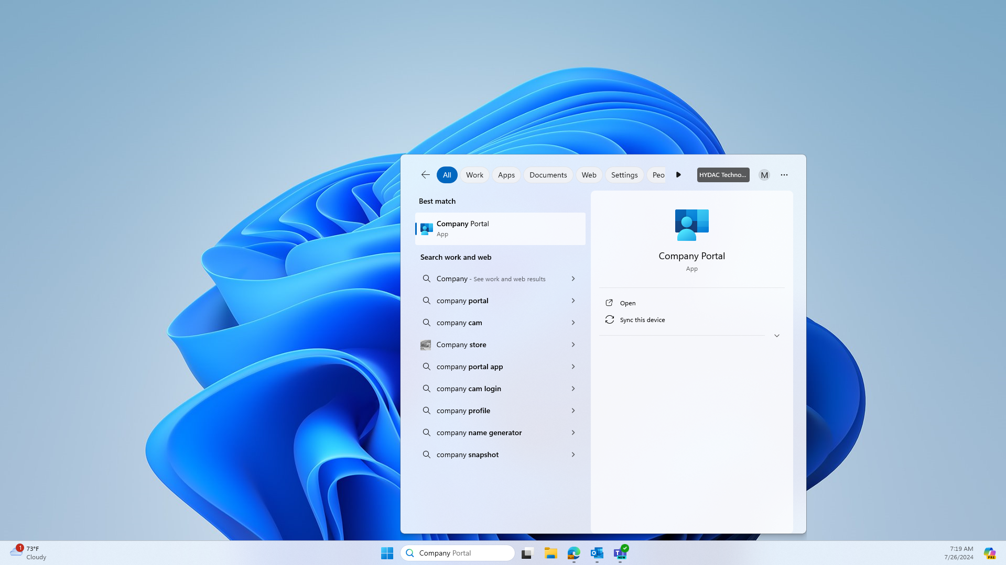

* 1. Launch the Company Portal and sign in with HYDAC credentials as prompted.
  2. The “Home” screen should be opened by default. If not on the “Home” screen, navigate to it as shown below.

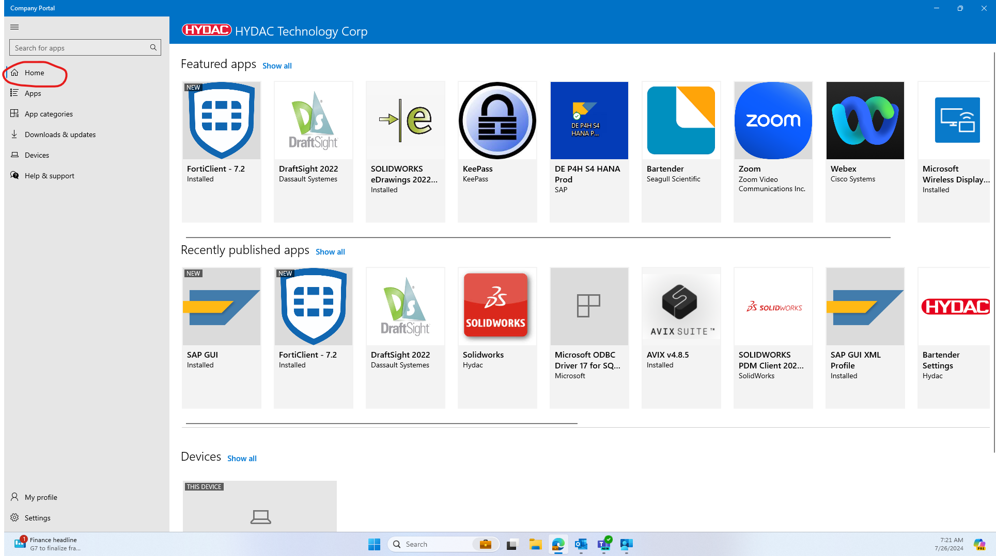

* 1. Now, in the “Search for apps” text input box, type the case-sensitive string “AVIX v4.8.5” (1) as shown and press Enter or the magnifying glass icon (2) in the corner of the text input box.

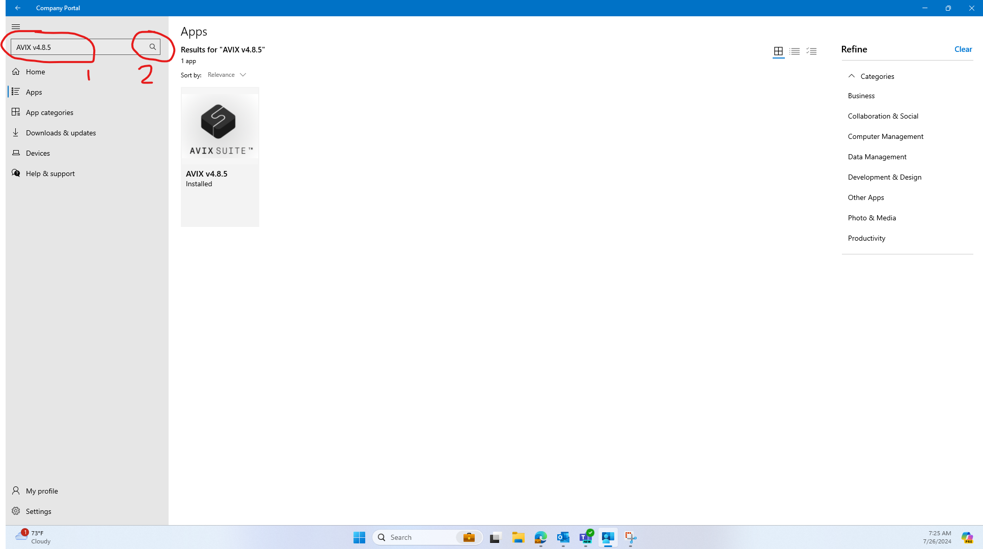

* 1. The AVIX v4.8.5 app should now appear in apps. If the app does not appear, consider submitting an IT Ticket or check the download permissions of the device. If admin permissions are not granted, downloads may be temporarily suspended on the device until permissions are granted.
  2. Once it has appeared, click on the AVIX v4.8.5 icon. The screen shown below should appear.
  3. At this point, the button in the upper righthand corner, shown above, should be labeled “Install” or in some cases “Download.” If this button is labeled “Uninstall” as shown, the app is already downloaded and there is no need to uninstall unless in the case of an external issue.
  4. Go ahead and download AVIX v4.8.5 now. The download should begin with an initialization and then a download. If asked “if the application can make changes to your computer,” allow all necessary permissions during download.
  5. Once installed, the Company Portal can safely be closed. To ensure the download was successful, type “AVIX” into the Windows search bar at the bottom of the screen. If the application appears as shown below, AVIX Suite was installed successfully. If not, backtrack steps and repeat.

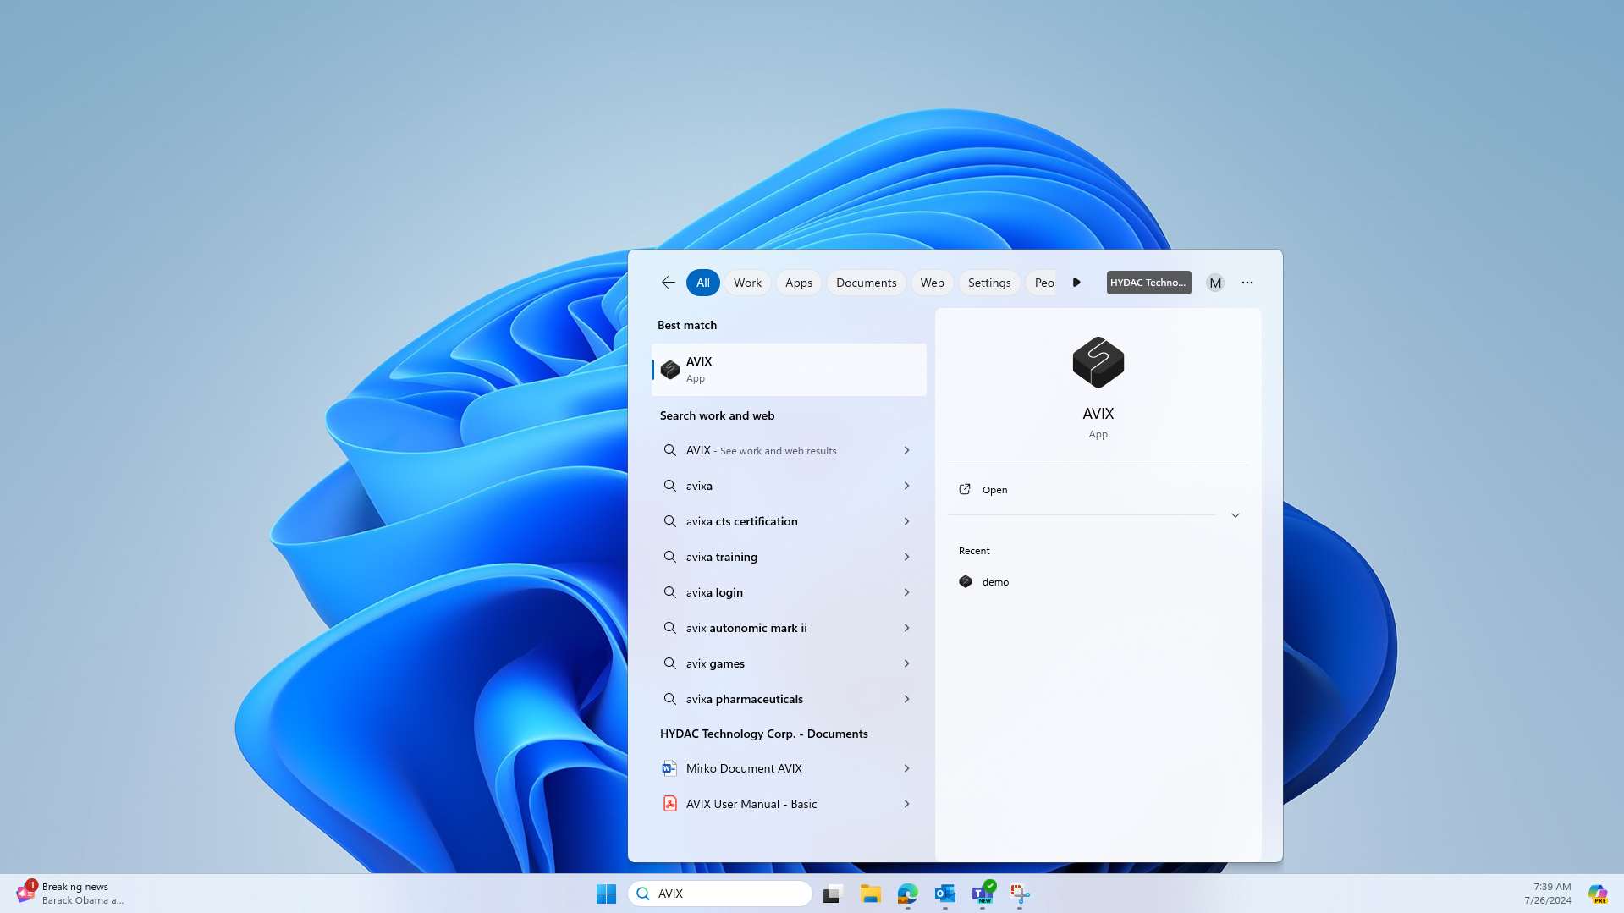

1. **HYDAC International Floating License Access**
   1. This section details the process for gaining access to AVIX through the HYDAC NA floating license.
   2. Firstly, assuming AVIX v4.8.5 has been downloaded, open the application through the Windows search bar. If the application has not been installed or cannot be located, reference section 5 “Download AVIX Suite” above.
   3. When opened without AVIX, the dialog box shown below should appear. Select the “Floating license” button and continue.

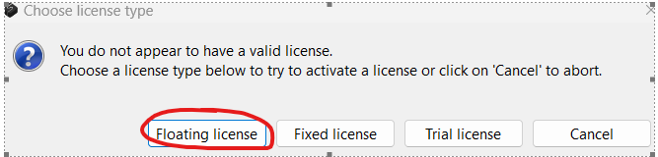

* 1. After selecting “Floating license,” the “Activate floating license” dialog box should appear below. The only difference from the one shown below is that it should have a blank table and no server. Proceed by selecting the gear icon in the top right corner as shown.

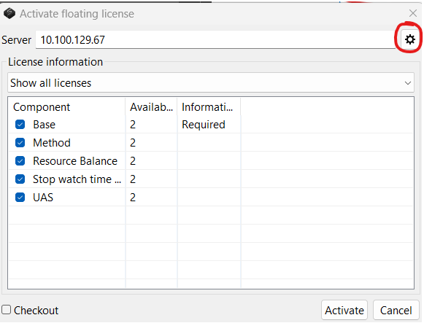

* 1. Selecting the gear should open a second dialog box like the one shown below. Enter the following sensitive HYDAC information seen in the image below and verify it matches. Make sure “Force no proxy” is checked and the “Source” is a File. Once the server IP address is typed in as shown, most of the boxes should be filled in. If trouble arises with this step, consider submitting an IT Ticket.

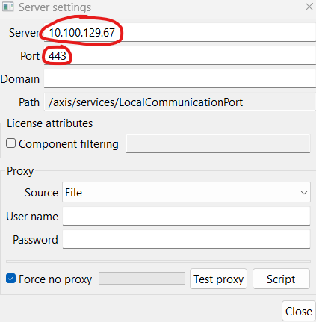

** This IP address and path credentials are extremely sensitive HYDAC information. To ensure that AVIX can continued to be shared around HYDAC NA, please do not share this information externally for any reason. **

* 1. Once the information is correct, press “Close” in the bottom right corner as seen above.
  2. Pressing “Close” should return to the “Activate floating license” dialog as seen before. This time, a green progress bar should indicate that the information is being processed. This loading time typically takes 2-5 minutes. Wait for the bar to disappear before continuing.
  3. Once the bar disappears, the window should display available licenses such as those shown below. Select all and then click “Activate.” If the “checkout” option is not selected in the bottom left corner as shown, AVIX floating access will last for a default 24 hours.
  4. Once “Activate” is selected, AVIX should be launched. To get instructions for working with and navigating AVIX, refer to the following sections or the AVIX user manual referenced in the introduction.
  5. Note that the best resource for help with gaining access to AVIX will be with an IT Ticket or a direct email to Kai Daniel. If no licenses appear or the server IP is changed, refer to one of these resources for help.

1. **HYDAC Cooling – Denver Floating License Access**
   1. HYDAC Cooling – Denver does not currently have its own Floating License nor unique server IP address.
   2. While no unique license exists, refer to the steps in “6. HYDAC International Floating License Access.”
   3. This section should be updated when/if a new license for the HYDAC Denver location is purchased.
2. **Recording a Work Instruction Video** 
   1. This section will detail methodology for recording a video for use in AVIX. These instructions can be followed using any device with a backwards camera and internet or email access. This includes Personal Phones, Tablets, Webcams, and Go-Pros.
   2. First, record a video of an assembly from start to finish. Begin with a clear workstation and end when the product is packaged or placed in a box.
   3. Videos should be 4-15 minutes in length and filmed from the operator’s chest and below. When the operator walks, film their feet. The overall goal is to get a steady, clear video of just tools, parts, and hands as assembly occurs. Examples are shown below.

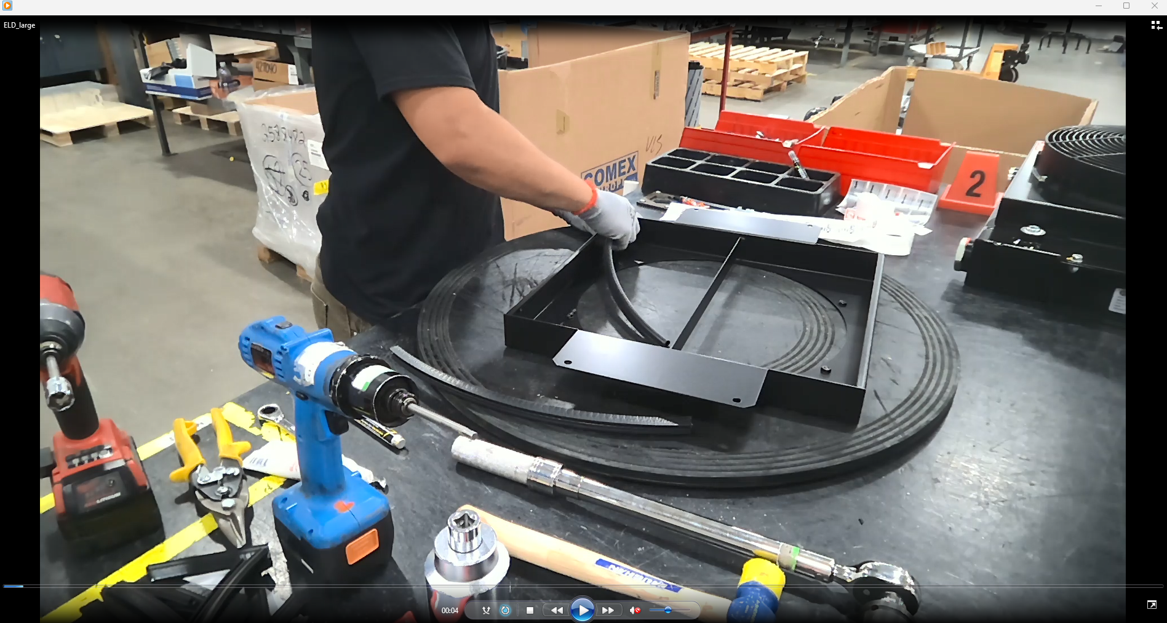

Chest-Level View

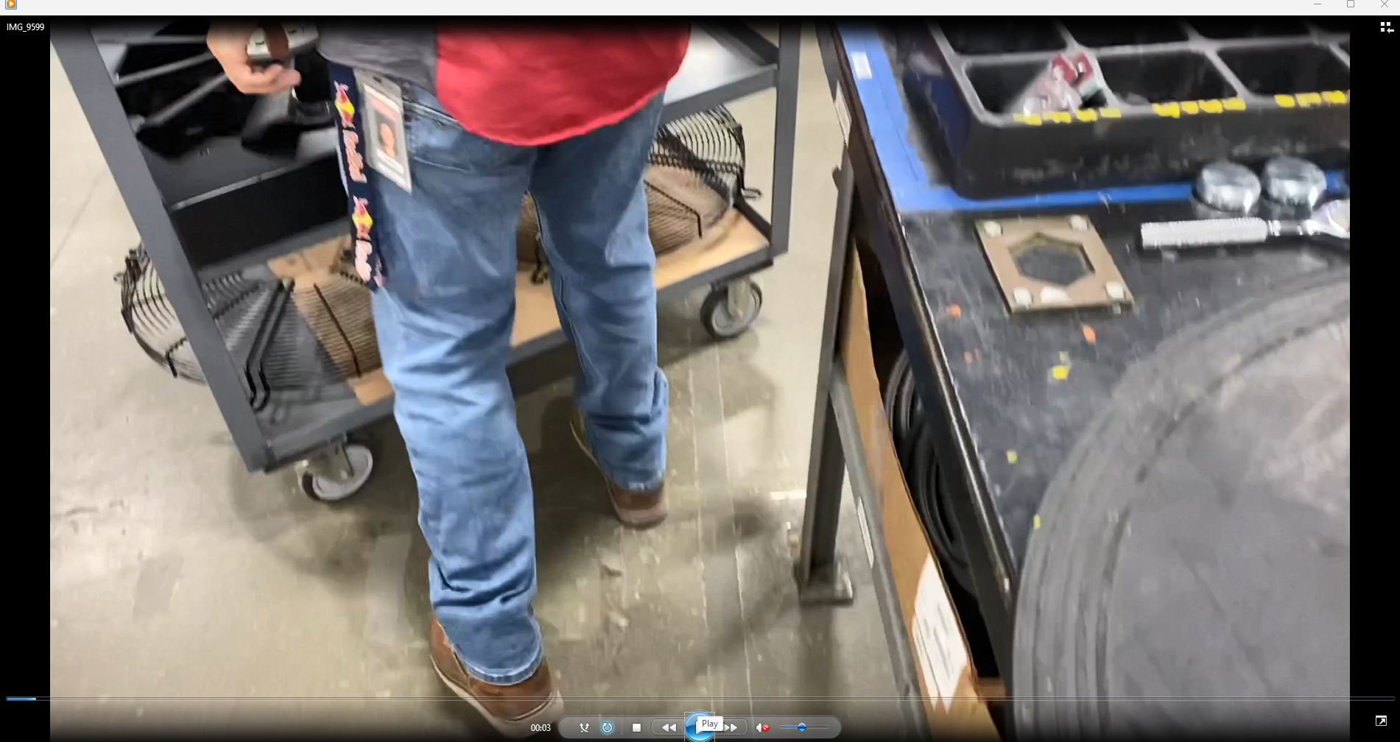

Feet Walking View

* 1. Once a video has been recorded, it needs to be sent to the same computer that AVIX is installed on. While there are a variety of methods to do this, Apple Mail Drop will be demonstrated below. Depending on the method of filming, the upload process may be different, therefore refer to information authored by the device’s maker, or contact IT.
  2. As an example, if the videos were recorded on an iPhone, it would be in the camera roll and have a .mov file extension. AVIX accepts .MOV, .MP4, .AVI, .WMV, .MKV, .WEBM, and other common video file formats. Therefore, the first step will be to locate the file in the device’s camera roll.
  3. After locating the video, attach it via email. This email will be sent to a HYDAC email address.
  4. Once the video is attached and a HYDAC email address is the destination, use “Mail Drop” when sending the file. Email processes are demonstrated below.

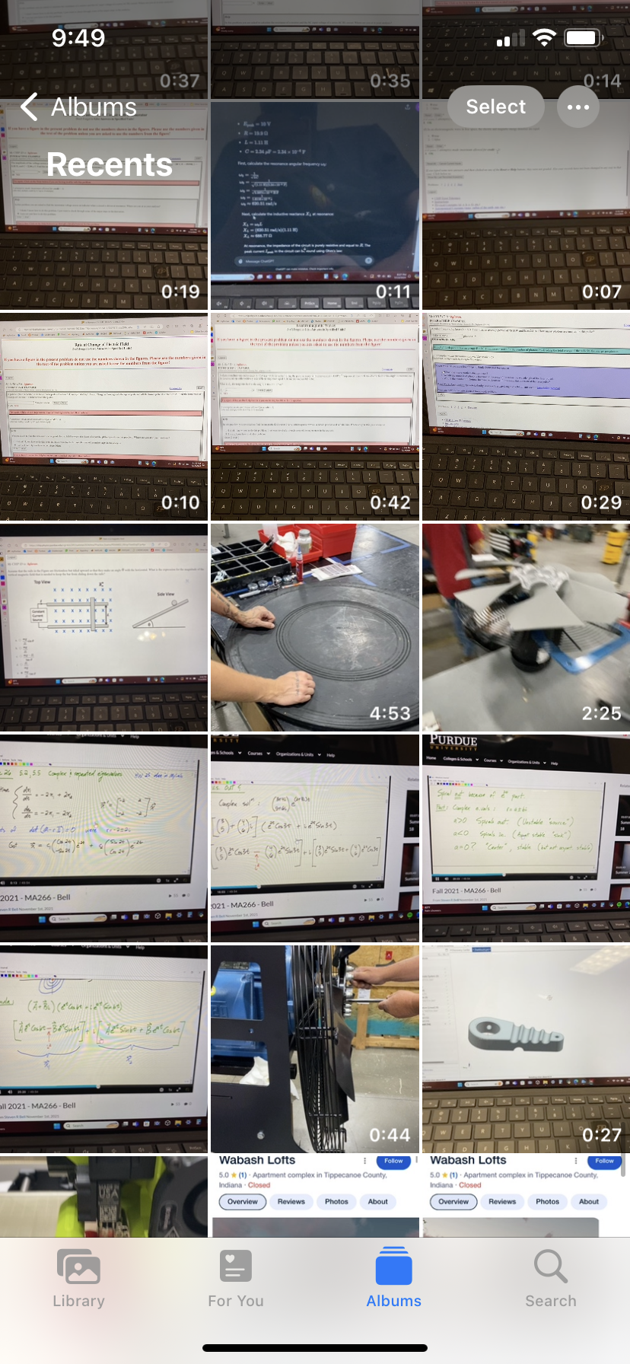 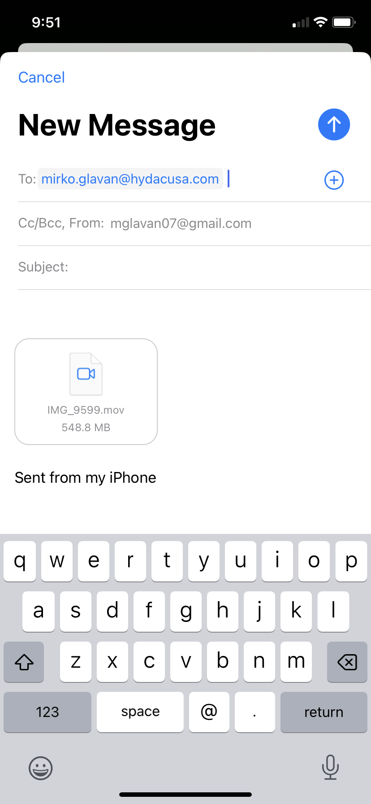 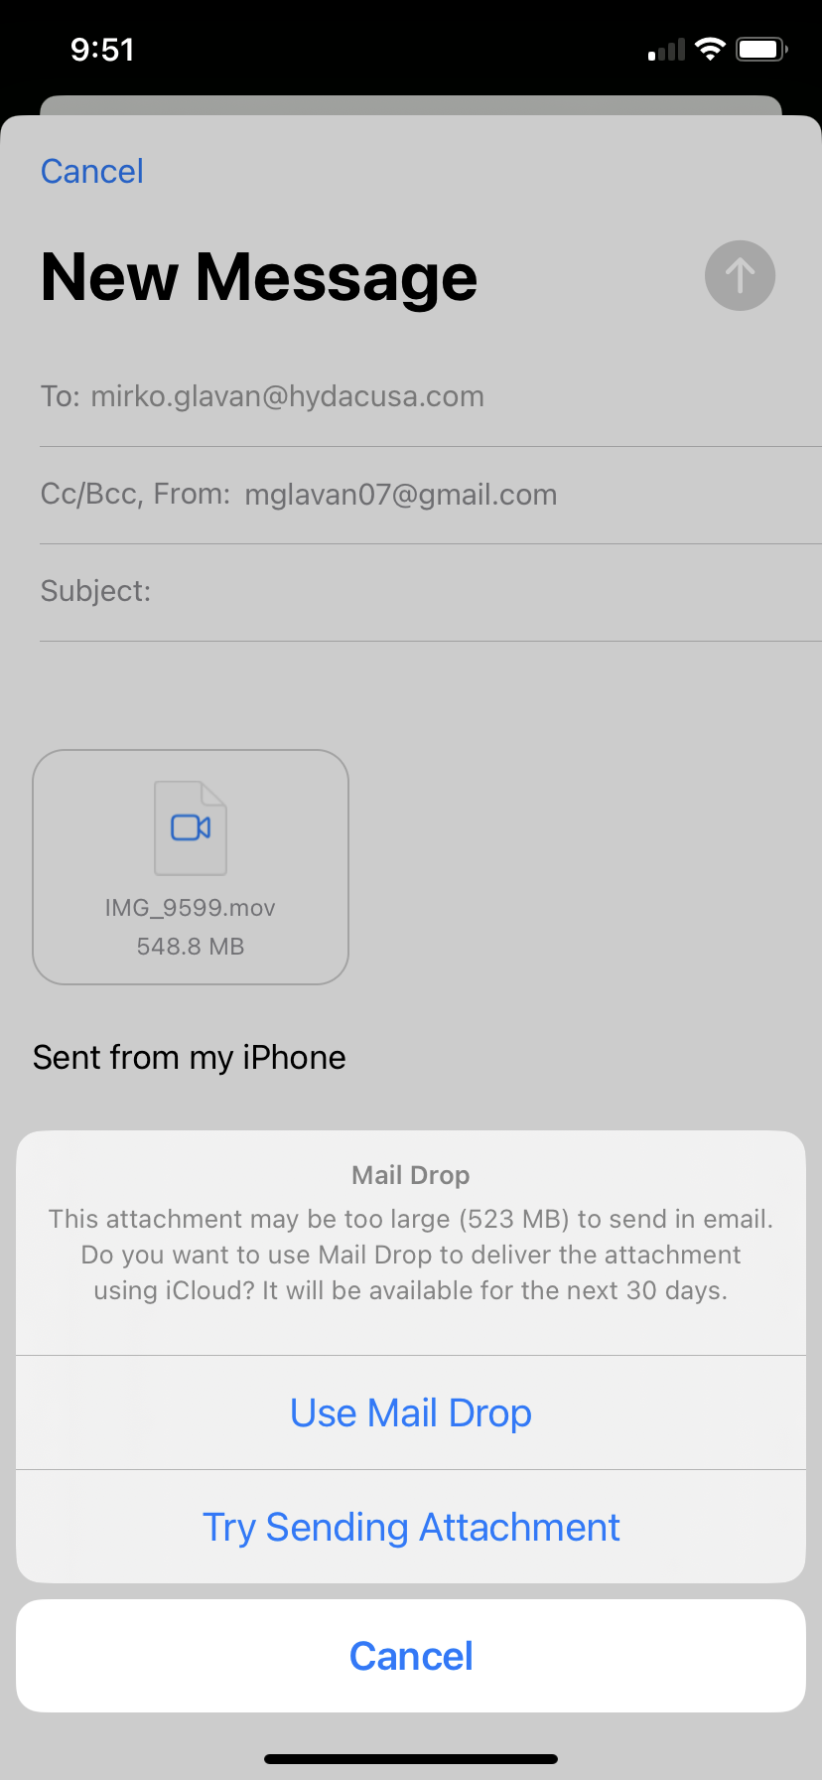

* 1. Navigate to the HYDAC email on the AVIX-installed device and open the Mail Drop link. The link should open an iCloud webpage with a downloadable .MOV file. Download this file. It may take up to 10 minutes for the file to send depending on its size.

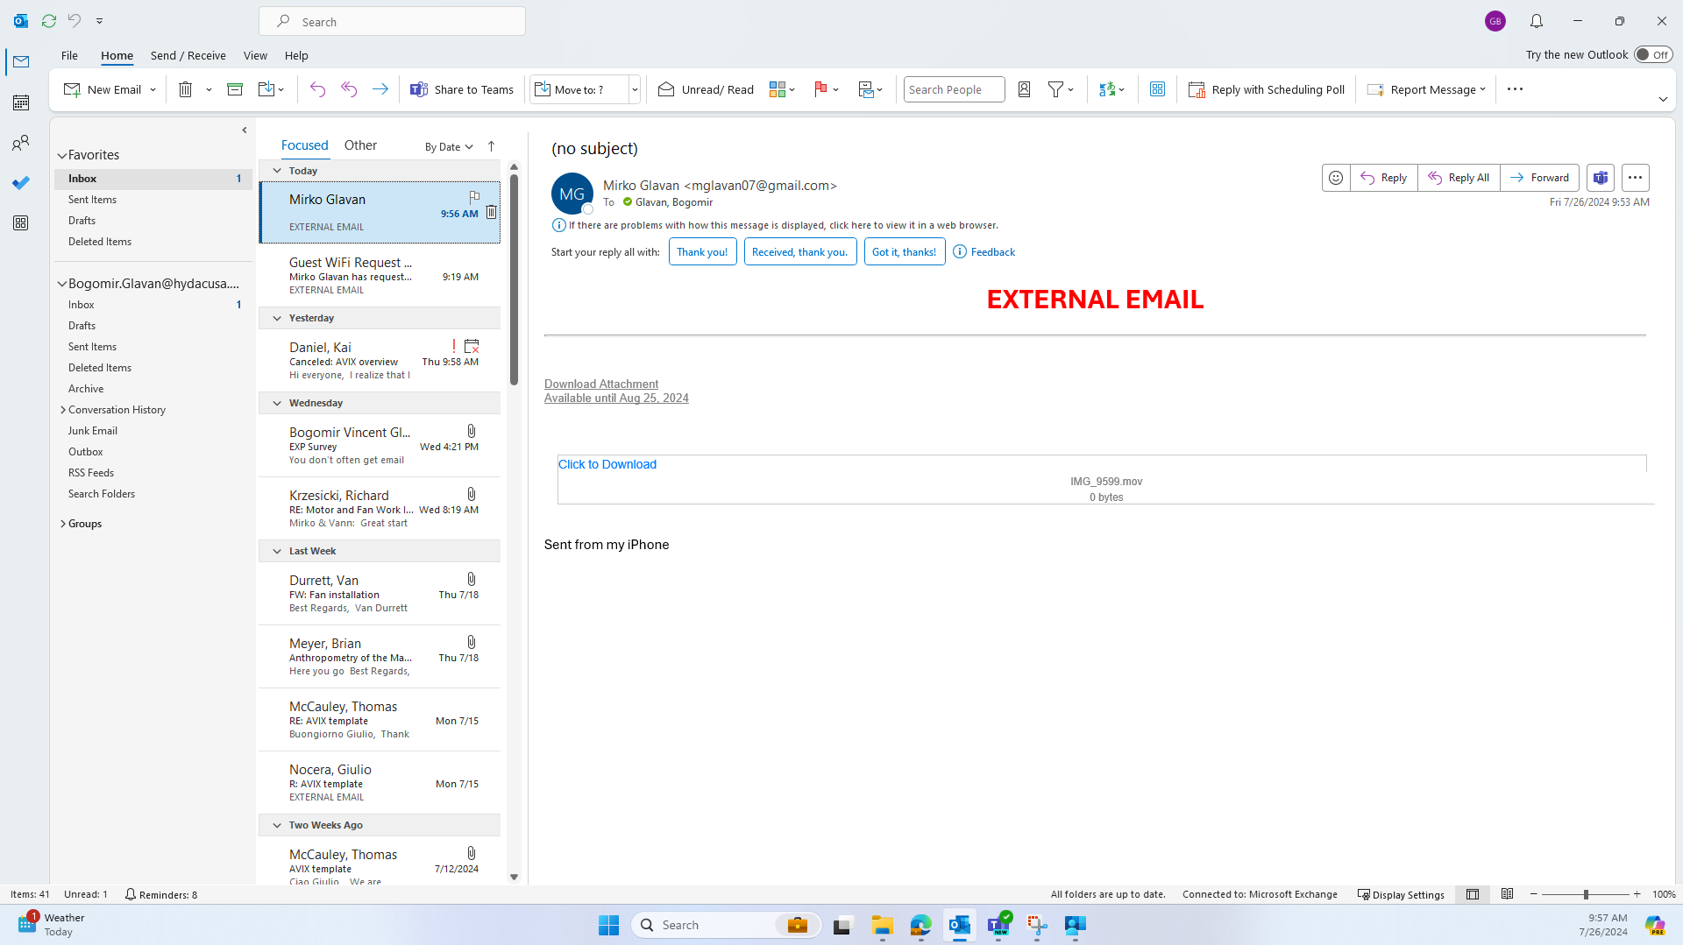

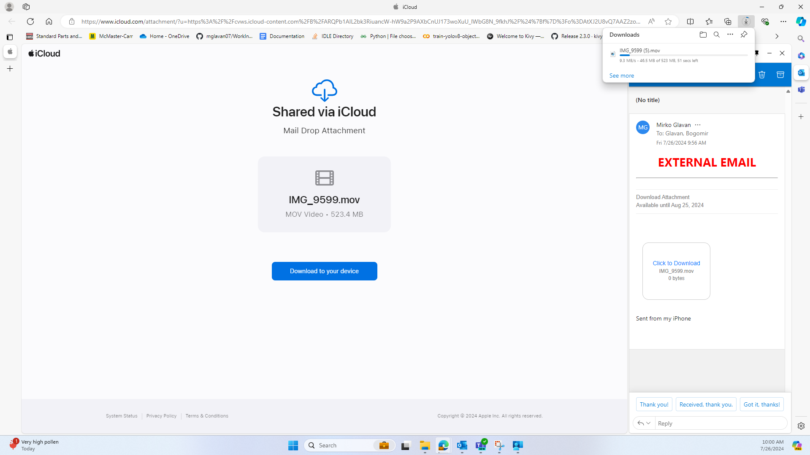

* 1. By default, this file will be sent to the “Downloads” folder. Navigate to the “File Navigator” app on the computer AVIX is installed on and move the .MOV file to the desired folder. A folder is recommended for all videos for organization.

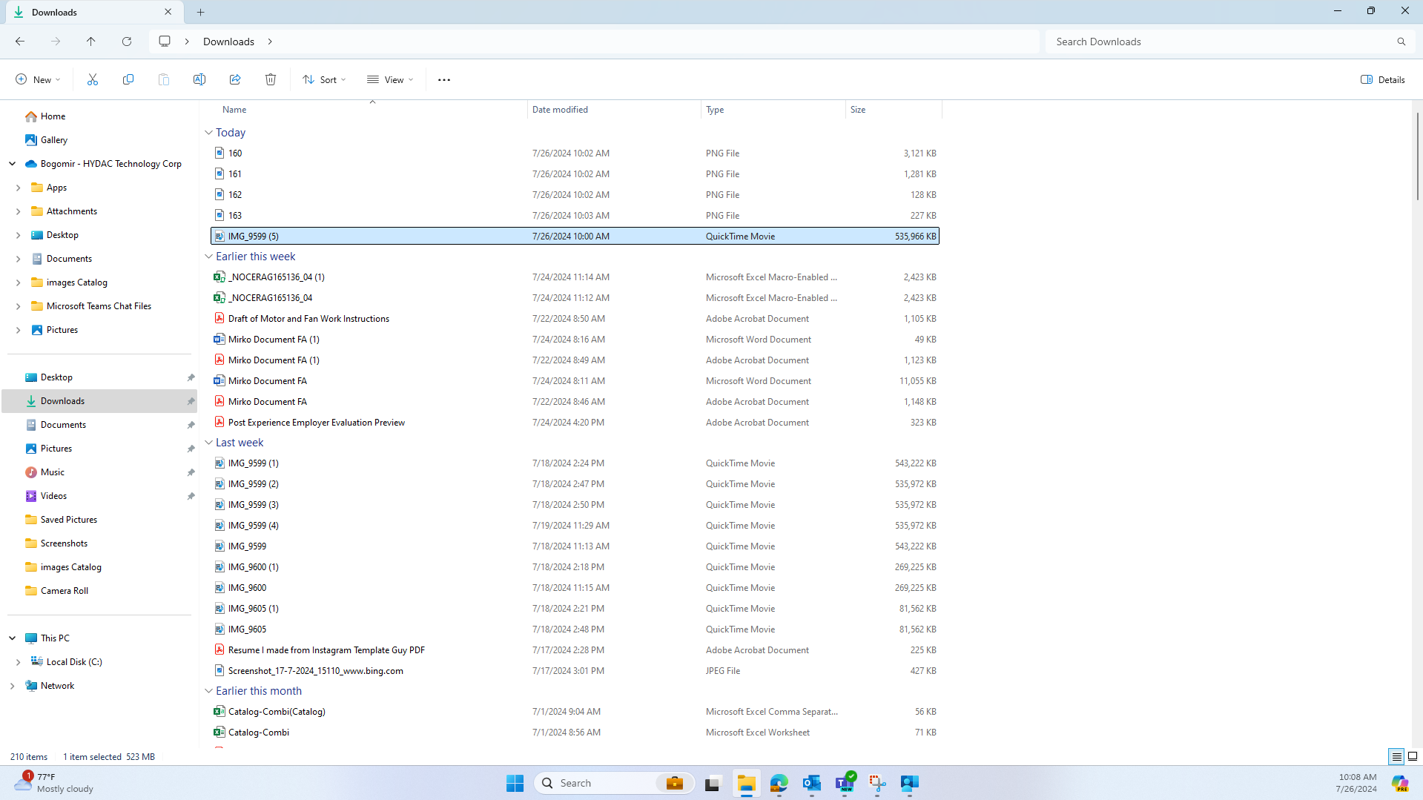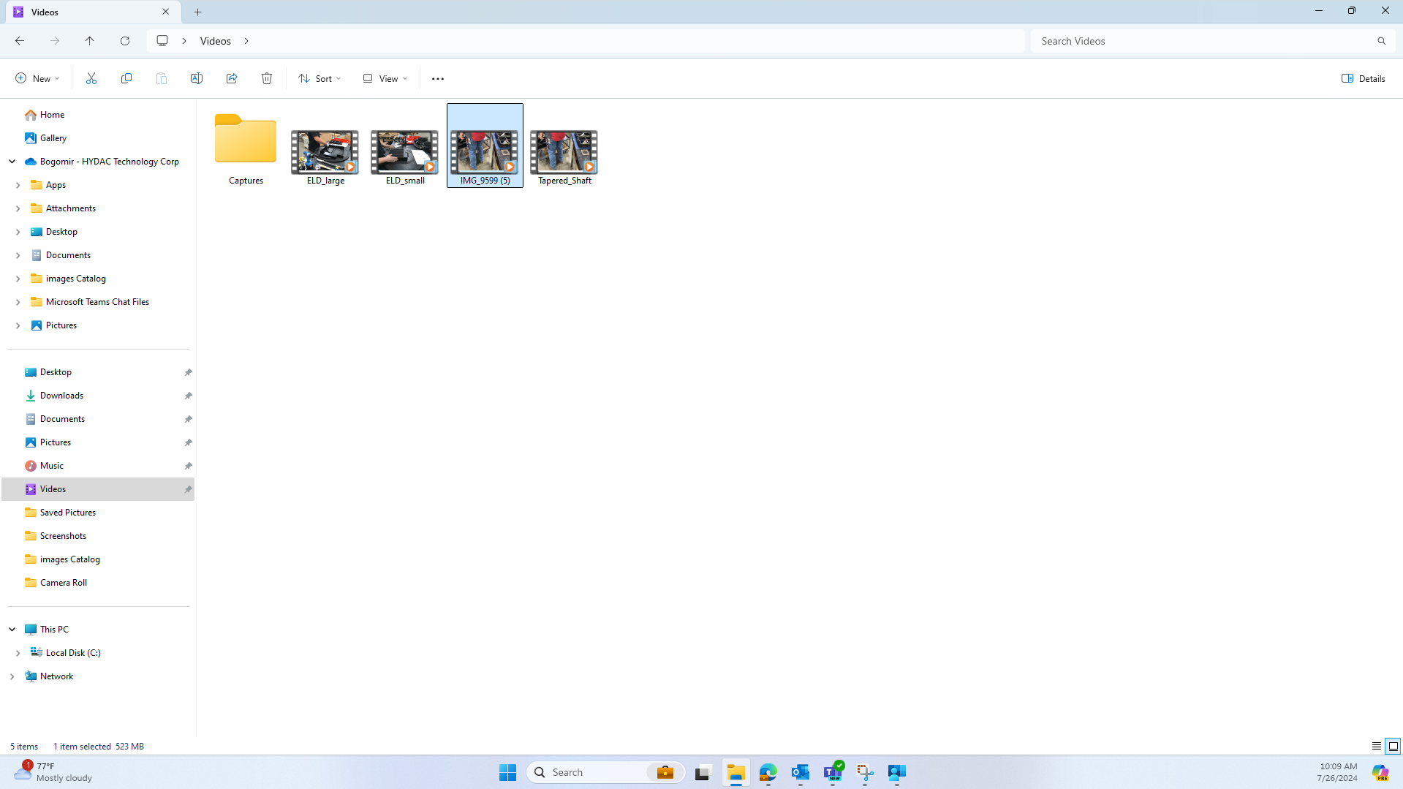

* 1. Once the video is organized into the correct folder on the AVIX-installed computer, enough information is now stored to create digital Work Instructions. To continue, repeat this process with another video, or launch AVIX and move to “9. Navigating AVIX Suite.”

1. **Navigating AVIX Suite**
   1. This section will detail some of the basic, necessary functions for setting up AVIX upon first opening, as well as a fundamental guide for getting to Work Instructions.
   2. For a more detailed view of AVIX’s functions outside of Work Instruction generation (such as Time Standards, Ergonomics, FEMA, SMED, or AVIX Method Loss Assessments) see the User Manual attached in the introduction.
   3. Firstly, when opening AVIX, a hierarchy must be made for the plant. A factory must be made first by pressing the icon and filling out the information shown below.
   4. In a similar fashion, make a Building and Line inside the factory by clicking on the factory and adding each in the desired order. A hierarchy should start to be built in the lower left “Method Tree” as information is filled out.

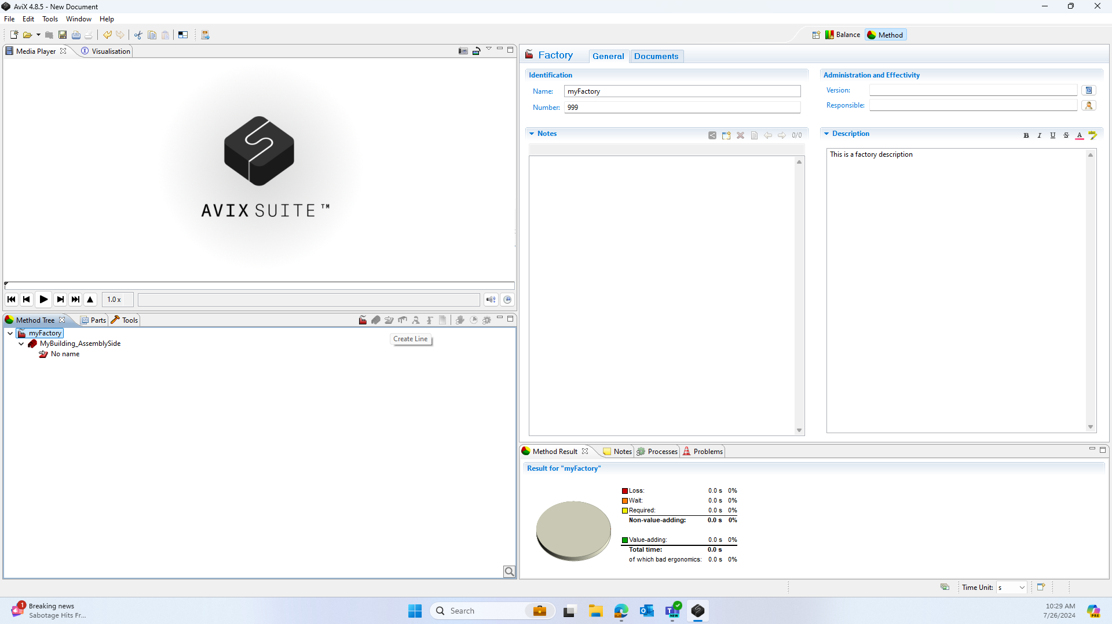

* 1. Now we can add a “Table.” Think of this as one of the tables the operators assemble on. We can also add named operators, but this is not necessary to make Work Instructions.
  2. Before importing the video, we must do one more round of “housekeeping” to ensure that the information we need is in AVIX. Now, we need to import a catalog of tools and parts into AVIX for later use. As shown in the images above, there are tabs for parts and tools, but when we click on them, they are blank.
  3. To avoid importing every part one-at-a-time, we can simply use an Excel or STEP file to quickly fill these tabs in. Assuming a file exists with the required information, continue in these instructions, else seek out alternatives in the User Manual or with Kai Daniel.
  4. As shown below, navigate to File (in the top right of the screen) and then press Import. The following dialog box should appear.

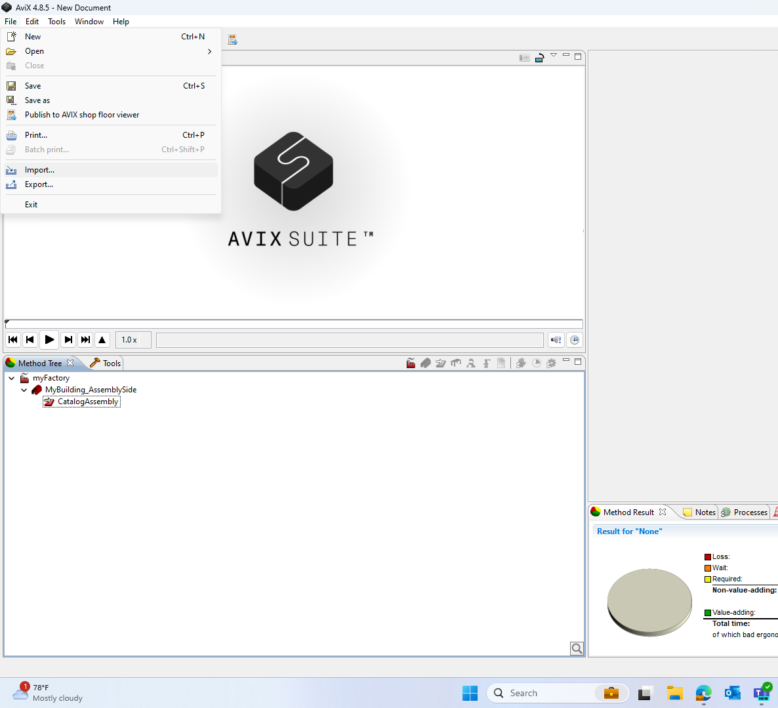 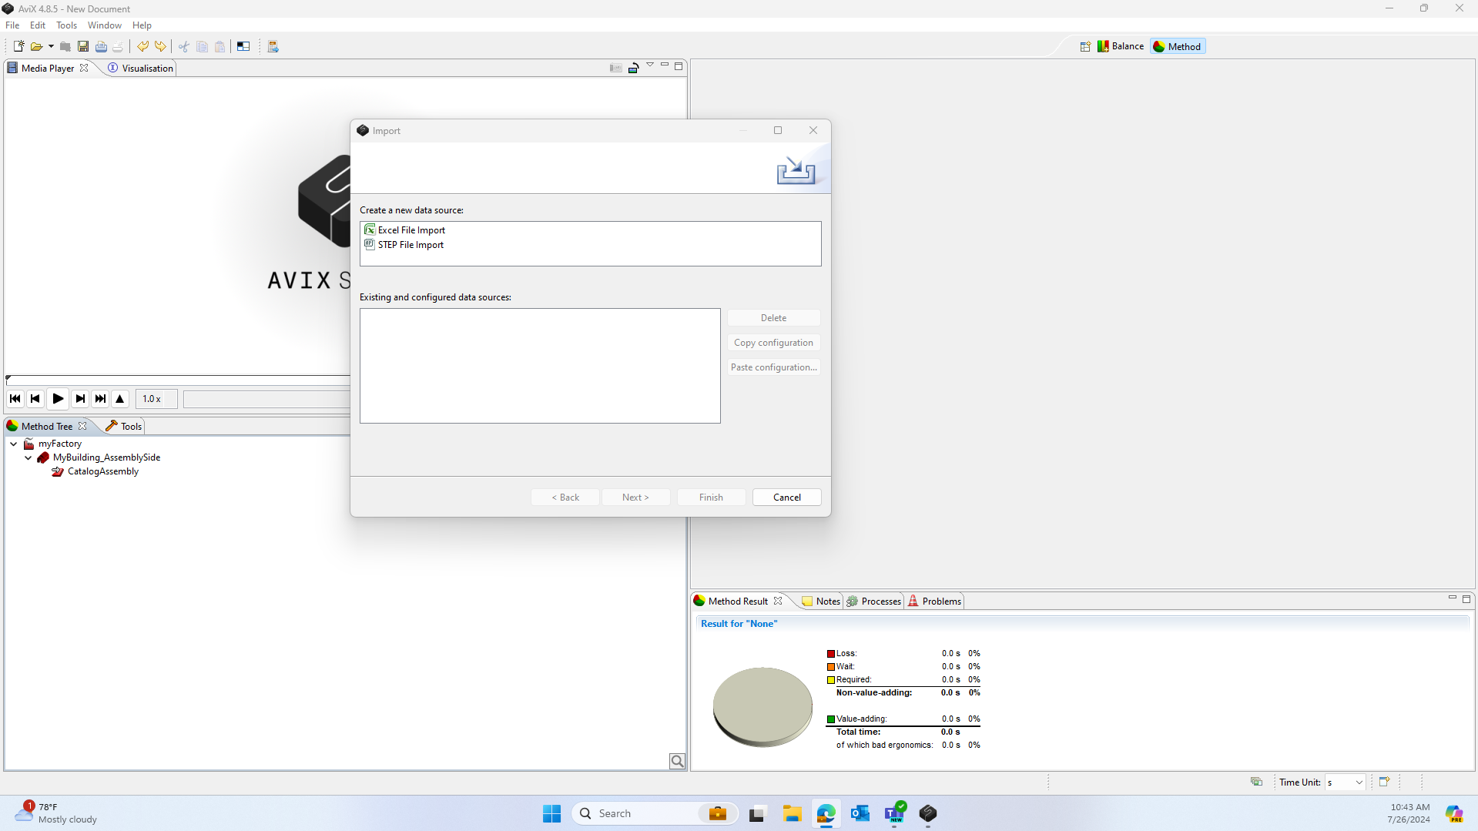

* 1. Assuming Excel is the type of data file, press Excel Spreadsheet in the Create a new Data Source dropdown and click next.

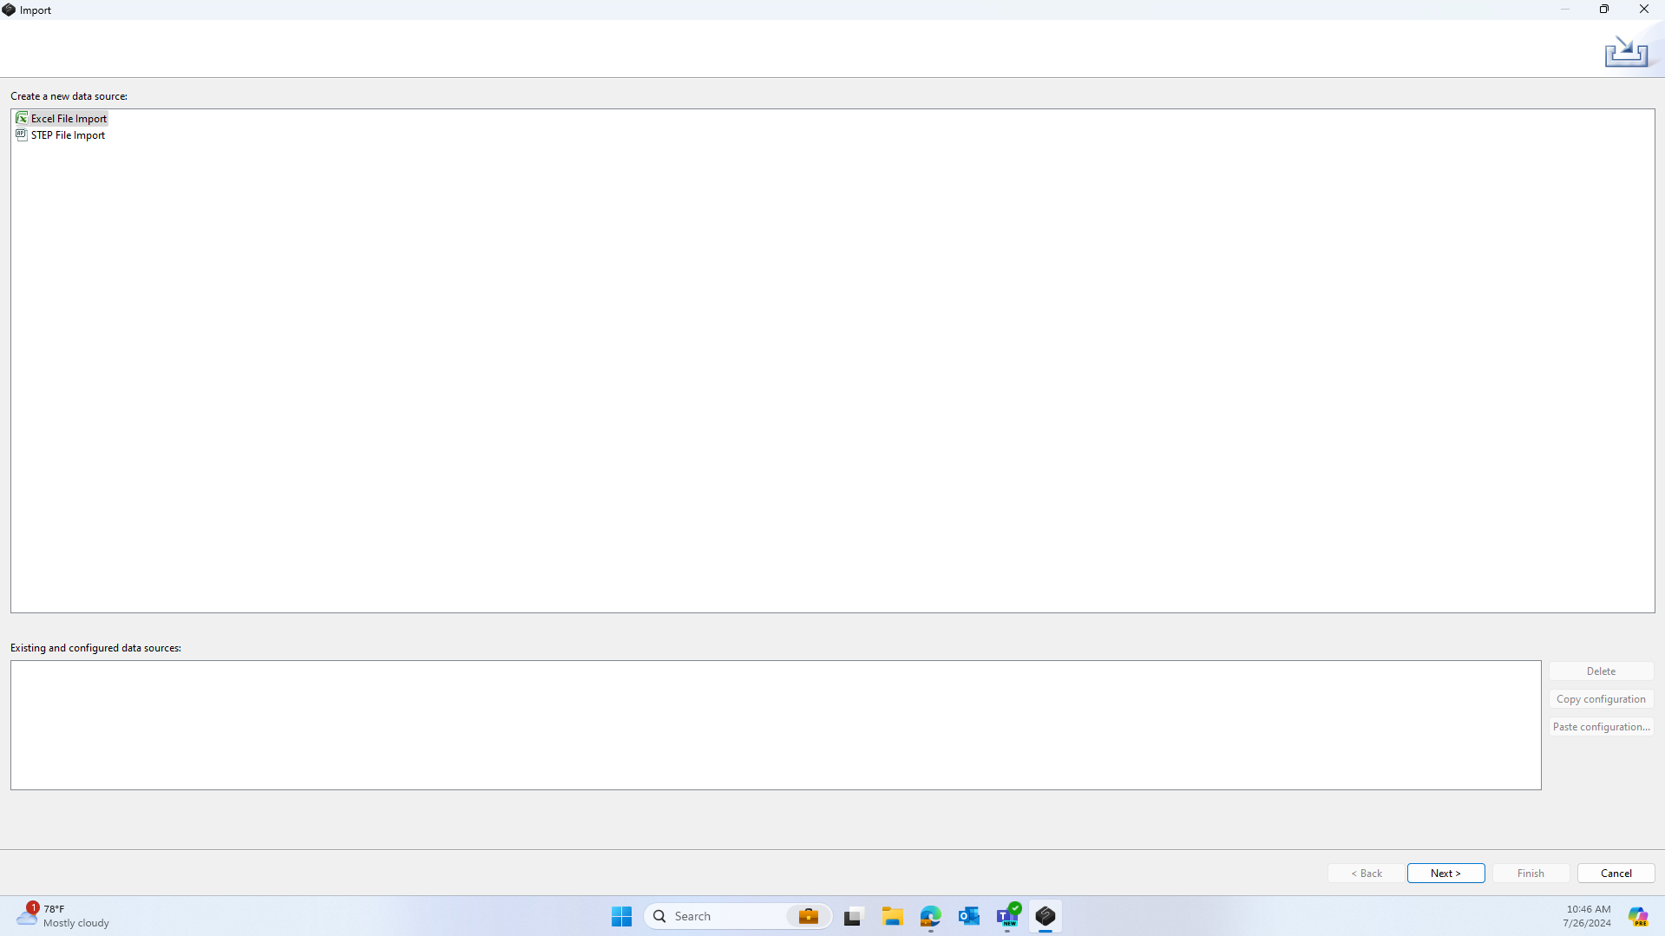

* 1. Now, insert the file by selecting the 3 dots in the upper righthand corner (1), and select the file with the correct information. Next define the Excel file as a part, tools, processes, or other import type (2). After doing so, associate each column in the Excel file with a category of information (3). It is recommended that, at minimum, names and part numbers are filled out and tool names entered. This is also where information such as tool images, part images, and various other bells and whistles can be added. For additional help with this step, contact Mirko Glavan, reference the user manual, or else contact Kai Daniel.

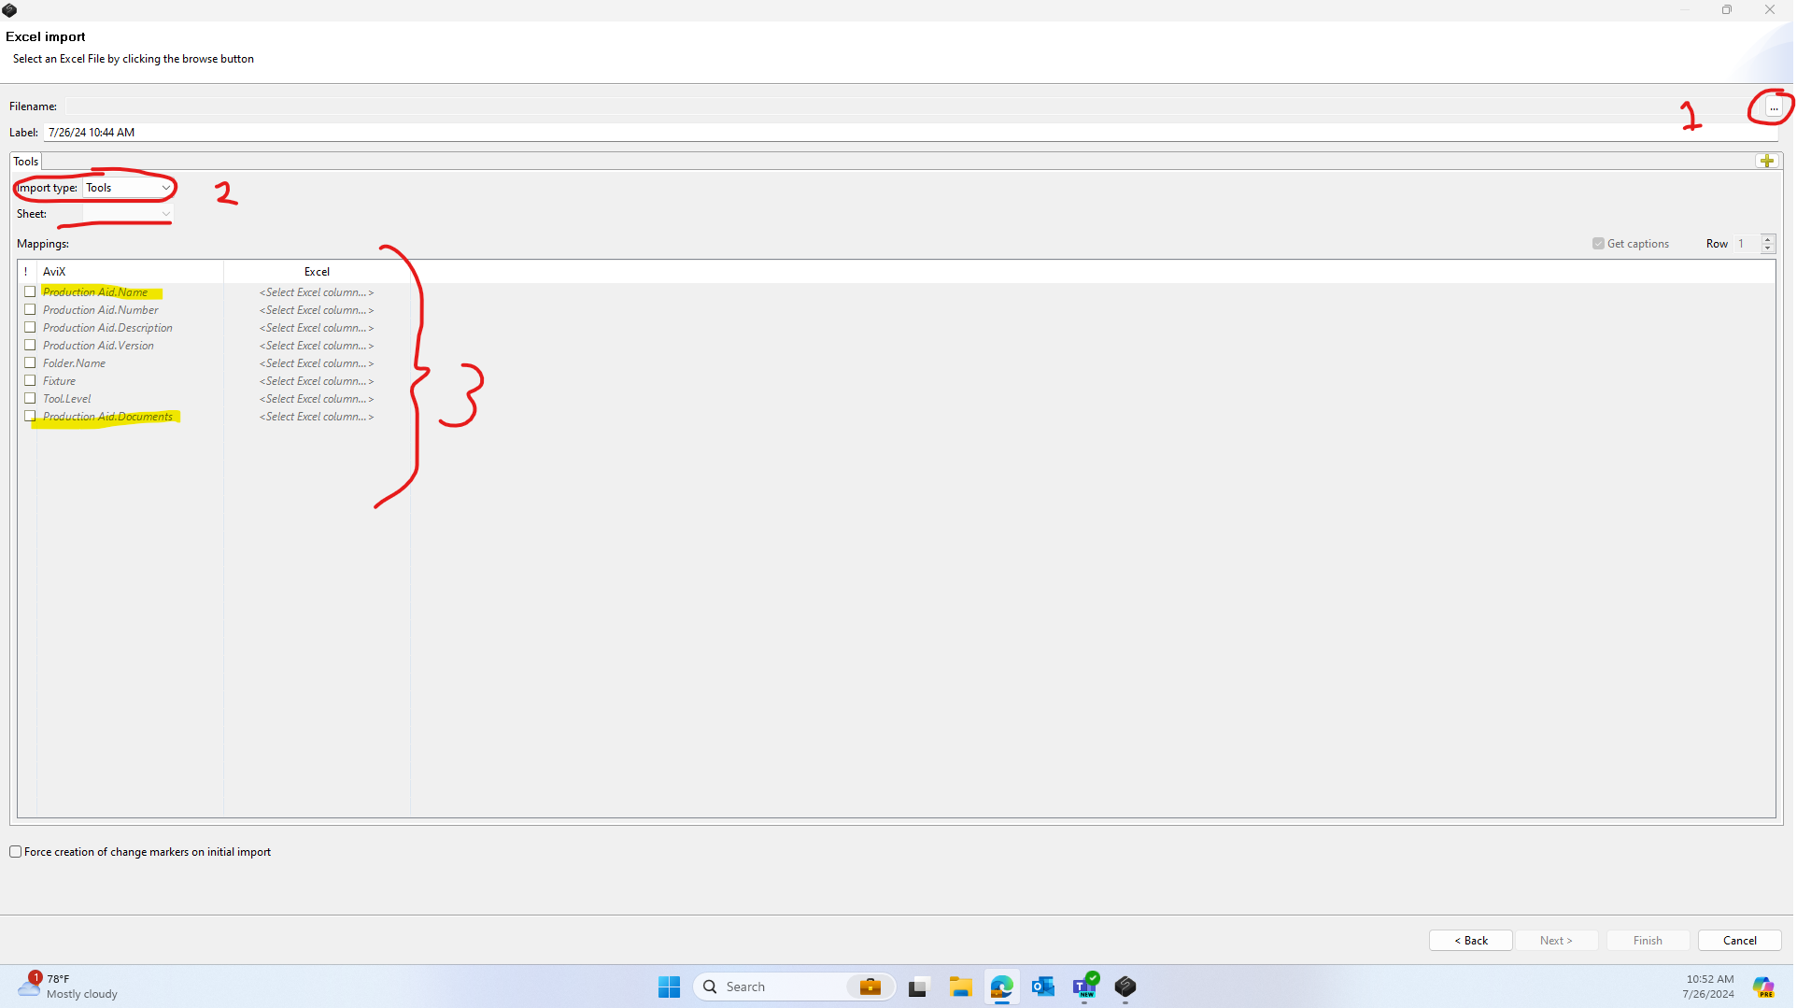

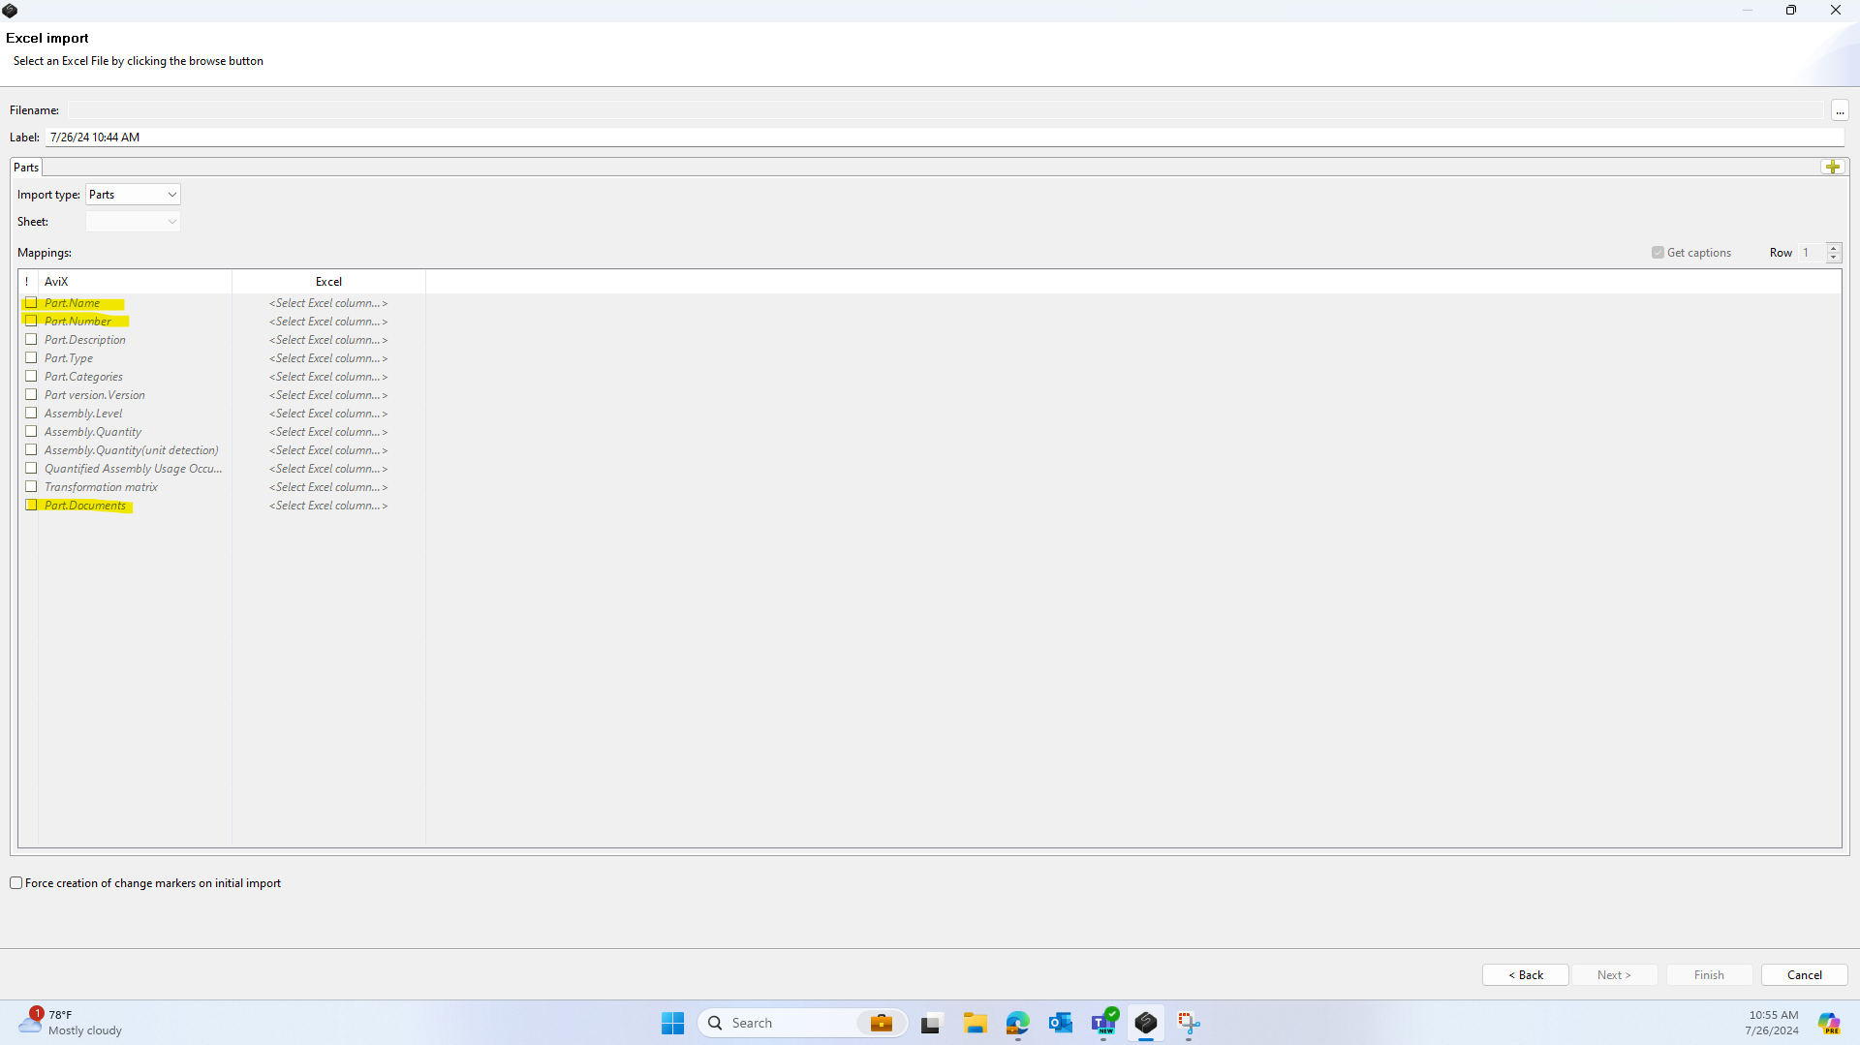

* 1. After this is complete, press “Finish” in the bottom right corner of the screen, and all data should be entered into the AVIX workspace file. Ensure that the file is saved after completing this step to avoid restarting (File Save).

* 1. Now, we may finally import the video to make work instructions. First, make a “New Task” underneath the desired table as shown below.
  2. As highlighted in the right window above, in the “Film Sequence” section, “Select” the video by inserting the file stored locally on your computer. See the earlier sections of this document for details in making and storing a video.
  3. Adding a valid video will prompt it to appear in the “Media Player.”
  4. Before finishing a step, make sure to give it a proper name, description, and timestamp. Also, make sure to associate the proper tools and parts when they appear in the “Used parts” and “Used tools” areas. If the boxes remain blank as seen in the demo, check to ensure that part and tool data were imported or reference the user manual.

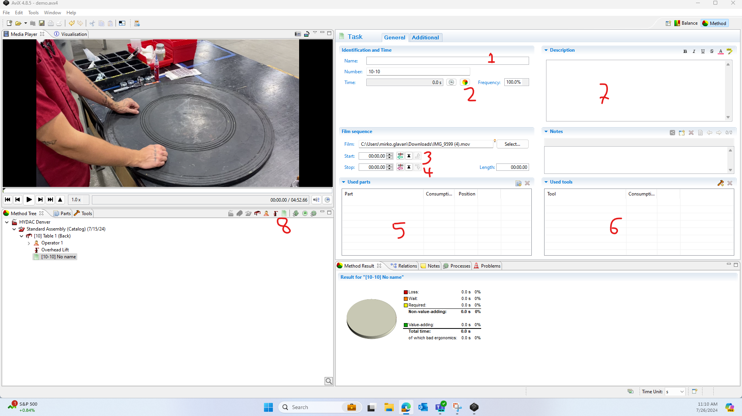

* 1. The following steps will elaborate further on the step-making process after the video file was added.
  2. As shown above in location 1, a name should be added to the step. This is something like “Attach Motor Guard” as the name should be short, objective, and descriptive.
  3. In location 2, classify the work as one of AVIX’s loss types. While this is not necessary for Work Instructions, it starts filling in the pie chart at the bottom, which can be visually appealing. Selection can be arbitrary, or reference AVIX’s user manual for their exact definitions of the categories.
  4. In location 3, set a start timestamp from the video as the beginning instant for this step. There are three buttons in a row here being to (from left to right) set the current Media Player timestamp as the start, jump the Media Player to the start, and to take the start point as the previous step’s end point. Also, a timestamp can be manually typed into the “Start” box. It is recommended that the first step has t = 0, and all other steps take the endpoint of the previous step to prevent overwriting.
  5. Likewise in section 4, buttons exist for setting the timestamp for an endpoint. The buttons are identical to those in section 3, but the only difference is they set the stop time. It is recommended that the pink “set current position as stop” is used for each stop time, and after doing this, the “down arrow” at the end of the row is used to send this time to be the start of the next step.
  6. The general process for timestamping should be to either set a start time or automatically receive one from the previous step, play the video, pause the video in the Media Player when the step is over, set the stop time, and send the stop time to the next step.
  7. Note that making steps and setting timestamps is entirely up to the user, therefore an assembly can be broken into one or infinitely many steps, and the timestamps are entirely at the user’s disposal. Similarly, writing descriptions, selecting tools and parts, and attaching extra files solely the responsibility of the user.
  8. In sections 5 and 6, assuming they are not blank, select the parts and tools used in the step.
  9. In section 7, write a description of the step if applicable.
  10. Before finishing, navigate to the “Additional” window in the top center of the screen as shown. Here, extra images or notes for the step can be generated. One such feature, highlighted below, takes a screenshot from the video at the current Media Player timestamp and adds it to the “Documents "tab. Anything inserted here will appear in the final Work Instructions.
  11. Once the additional media has been inserted, navigate back to “General” next to the “Additional” tab.
  12. Finally, to create the next step, navigate to section 8 and “Create Task.” Repeat the task making process until the end of the video is reached.
  13. Remember, that, to set the end timestamp of one step to be the start of the next, a new step must be made in advance. This means that the user may need to create several blank “Tasks” before filling them out to ensure that the timestamps do not overwrite each other. If timestamp overwriting becomes troublesome, reference the AVIX user manual for further clarification.
  14. Finally, after making all the necessary steps to segment the entire video, organize the “Tasks” by making a “Process Group” as demonstrated below. A straightforward way to go about grouping tasks is to first select the table under which the “Tasks” exist. After the table is selected, right click inside the “Method Tree” and press “Create.” Now press “Task Group” and the window below should appear. Fill out the correct information.
  15. To add the steps to this “Process Group,” select all the tasks (without selecting the group) as shown and drag them into the process group.

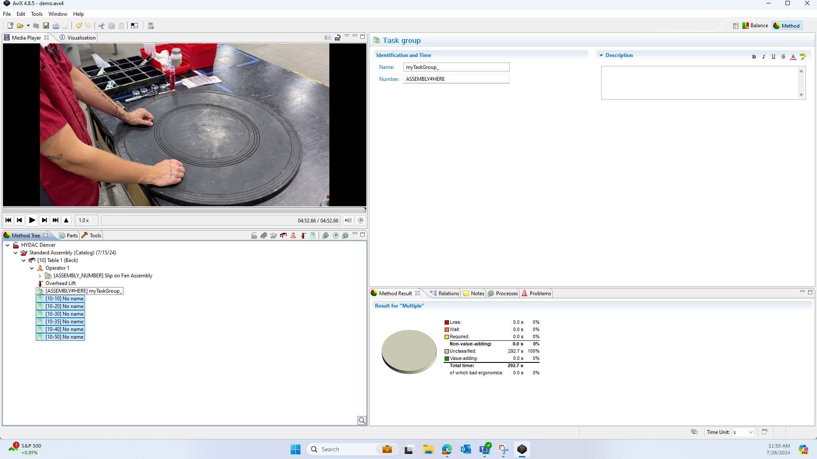

* 1. Each step should now be in order and organized in the hierarchy as shown below. After this information is complete and the user is satisfied with it, continue onto the next section to generate, and export digital work instructions.

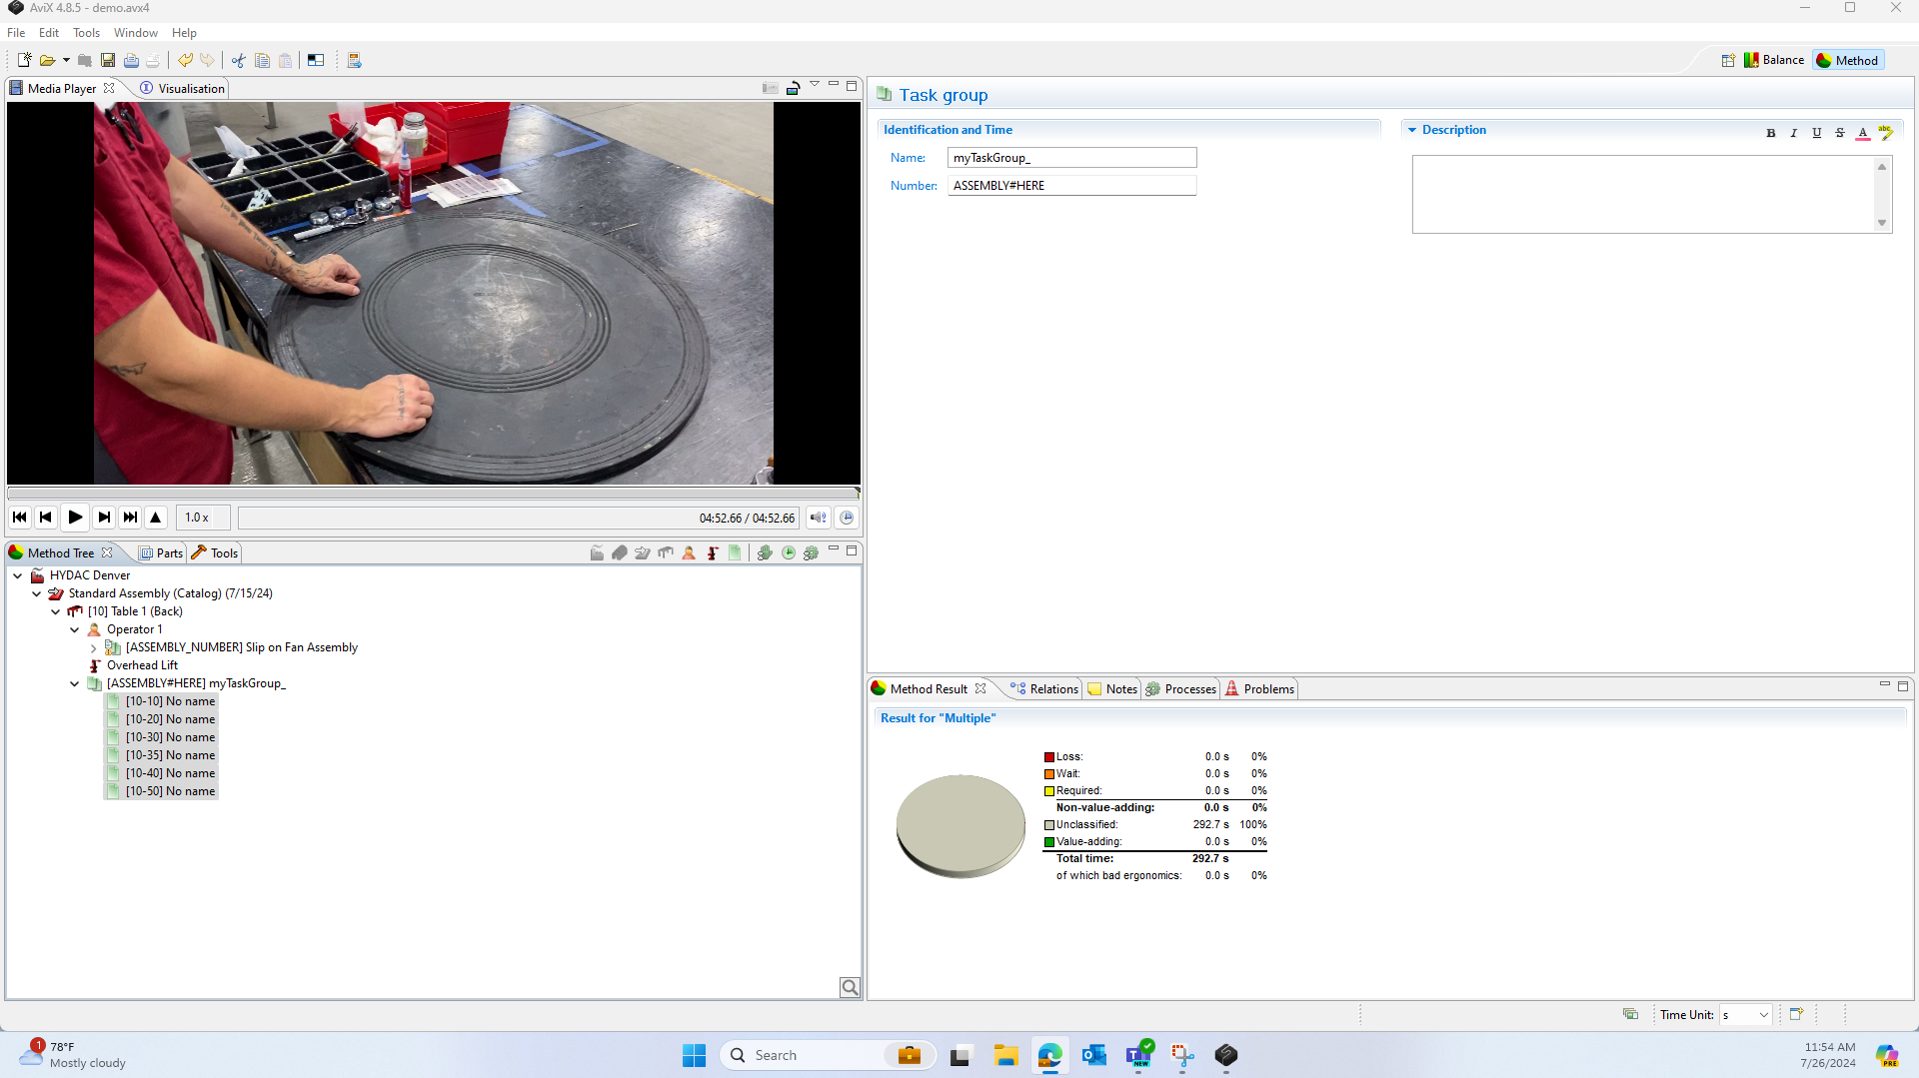

1. **Publish Work Instructions**
   1. Currently, exporting in IBS format is unclear, as without any modifications, AVIX Suite only gives the default instruction export options.
   2. If set on IBS format, contact Kai Daniel, IT, or an AVIX or IBS representative. Another option that exists for IBS exportation is the use of the Python Work Instruction generator created by Mirko Glavan. Documentation for this alternative is attached in the document’s introduction.
   3. If not set on IBS format, however, the rest of this section will detail how to use AVIX to export Work Instructions in one of its default formats.
   4. To begin, once a process has been filled out and assigned to a “Process Group” (see the above section for details), selecting the group should allow the printer icon in the top toolbar to become unhidden as shown.
   5. Click on the “Print” tool circled above. The icon appears next to the save icon. The dialog box shown below should now pop up.

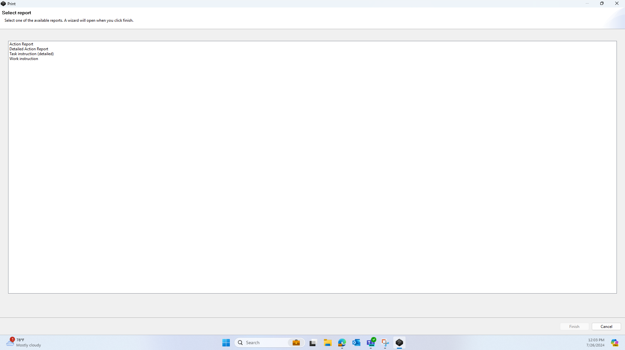

* 1. Select “Work instruction” from one of the default options shown above.
  2. Selecting “Finish” should progress the dialog box to the page shown below.

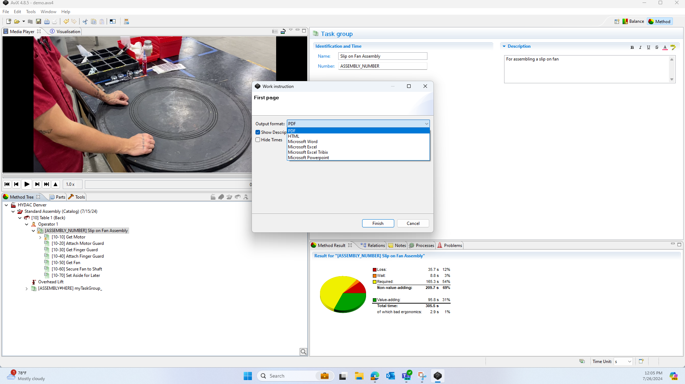

* 1. After choosing the preferred method of exporting, select “Finish” once again.
  2. Selecting finish should open the generated work instruction file automatically. As shown below, the file can then be saved locally, or exported to the destination of the user’s intent.
  3. At this point, the work instruction process has been completed. To make a new set of instructions, repeat these instructions with a new video and make a new “Process Group.” Ensure to save all changes into the same document and remain organized, because the AVIX structure is built around the assumption that all instructions are made within the same .AVIX file shared across many computers. This allows for tools and parts that were imported to be reused when creating other instructional documents.
  4. If looking to use a distinctive style other than the default for work instructions, or implement some of AVIX’s other functionalities, refer to the AVIX user manual or contact Kai Daniel for more information or tutorials.
  5. Again, it is highly recommended that a file storage infrastructure is built to contain all the .AVIX files, videos, and output instructions from AVIX. It is recommended that these files be segregated from other information, as AVIX has a noticeable tendency/bug that causes substantial amounts of duplicate image files to be pushed onto the hard drive of the computer in the same directory as the AVIX file.

This is the end of the document